*CASE STUDY NOTES*

**Marketing is about the 5 P's:**

* Product
* Price
* Place
* Promotion
* Perception

**Resources are the 5 M’s:**

* Money
* Machines
* Methods
* Man Power
* Materials

They don’t appreciate the connections between their info. They only view them as separate silos of info.

Map out the goals and objective you want to achieve

* Benefits point of view
* What needs to change to make them happen

Collaborations is KEY

Materials requirement planning

Customer relation management

Separate Gmail’s

Customer Record – Check credit – Create order – Sale – Send Invoice

Allocate stock- Pick, Pack, Ship

Credit Limit is incorrect

Lower credit limit on traders than retaillers

Create relationship with delivery companies instead of doing it themselves

**Info must be:**

* Relevant
* Understandable
* Timely
* Accurate
* Complete

Segment

Target

Position

**CRM:**

* Capture and integrate customer data from all over the organization
* Consolidate and analyse customer data
* Distribute customer information to various systems and customer touch points across enterprise

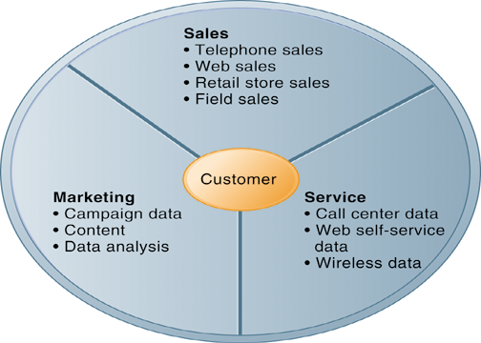

URL: Advantages of using Computerised Accounting Software

Itseducation.aisa/computerised-accounting.htm

**Tasks:**

Allocate and update CA Group

MCTV as it is

Take roll and think of challenges what are they doing how can it be done better

Spreadsheets, edit new sheet and add new fields

Customer – add email

Stock (i) ma stock (j)min stock etc.

Credit limit higher for retail

Trade aprox. 800 euro

Customer loyalty and segmenting market get more powerful data

Tutorial on data base

Database add county drop down for munster

Default values for stock, county i.e limerick, prefix

4th table possible for delivery for website orders

**Tables into excel**

Customer:

Email, post code, date of pur, preffer con, preferred deliv

Supplier:

Company number,, email, post code,delivery METHOD, company numb

Inventory:

Max stock, min stock, default stock

Delivery:

Date of purchace, prefer contac, preferd delivery, email, porst code, add 1 2 3, name, phone numberDA

email, post code, date of purchase, age group, preferred contact method, delivery method, company number